Web dev assignment lighthouse

Matthew Spriggs

Lighthouse did not like the fact that I made this heading smaller that the rest of the text, this was intended in the design but for accessablility purposes I altered this so the heading was at a more appropriate size.

In the footer I had some links for the ‘Contact us’ part, these links were meant to be somewhat small as they were in the footer but, once again, for accessablility I made the spacing of these links much bigger.

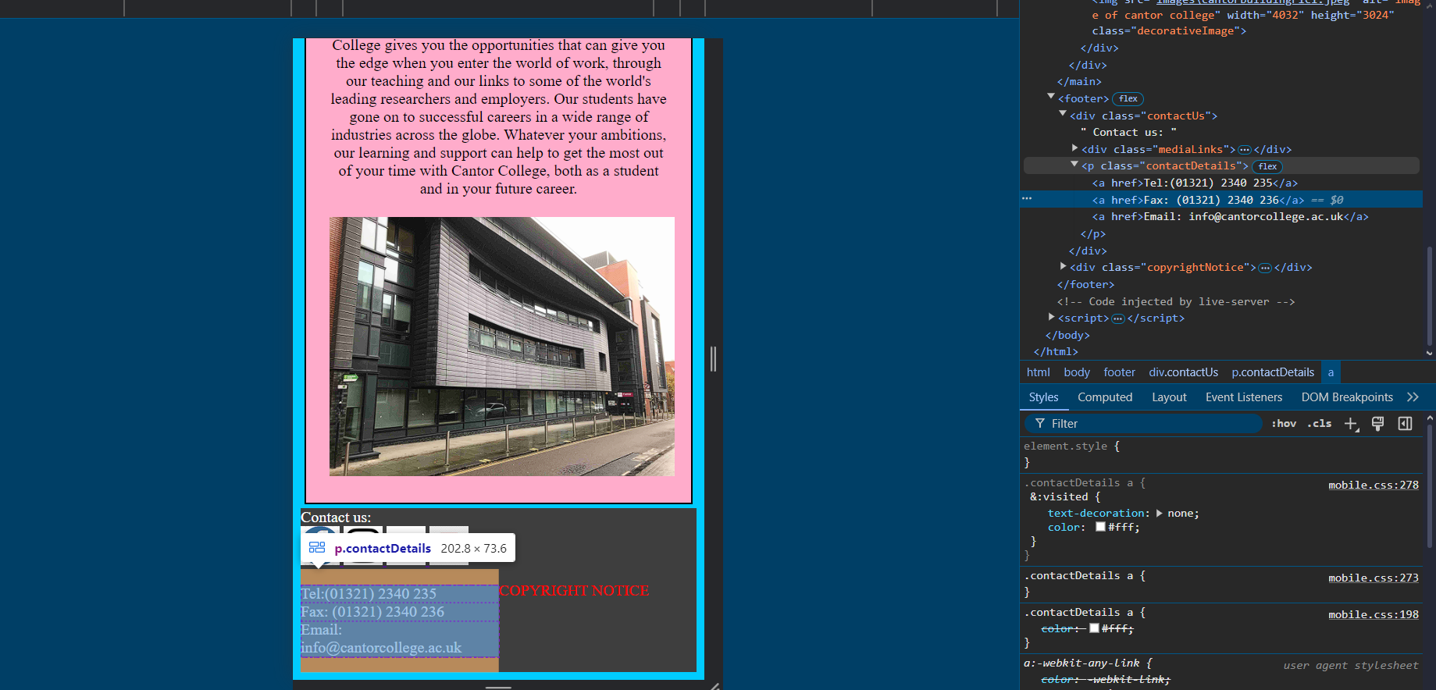

Lighthouse was still not happy with this so I made the space even bigger.

